**AI LAB 7.3**

Name:V.Nithya

Hall ticket no:2403A52346

* **Task1:** **Paste a function with a missing colon (add(a, b)), and let AI fix the syntax error.**

**Corrected code:**

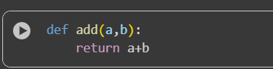

**Explanation:**

**Task 2:** **Identify and fix a logic error in a loop that causes infinite iteration.**

**Corrected code:**

**Explanation:**

* **Task 3:** **Debug a runtime error caused by division by zero. Let AI insert try-except.**

**Corrected code:**

**Explanation:**

* **Task 4:** **Provide a faulty class definition (missing self in parameters). Let AI fix it.**

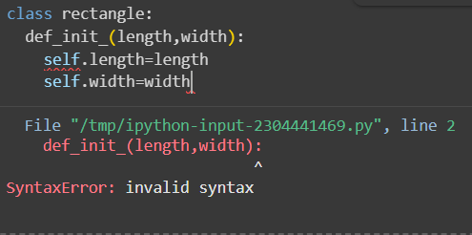

**Corrected code:**

**Explanation:**

**Task 5:Access an invalid list index and use AI to resolve the Index error.**

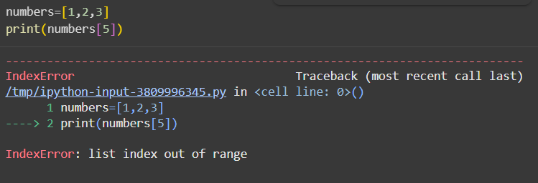

**Corrected code:**

**Explanation:**

